Polish Association for Irish Studies

would like to cordially invite you to our first talk celebrating the twenty-fifth anniversary of the Good Friday Agreement

‘Good Friday Agreement after 25 Years: Reflections from Northern Ireland’
will be delivered by

Professor Jan Jędrzejewski from Ulster University

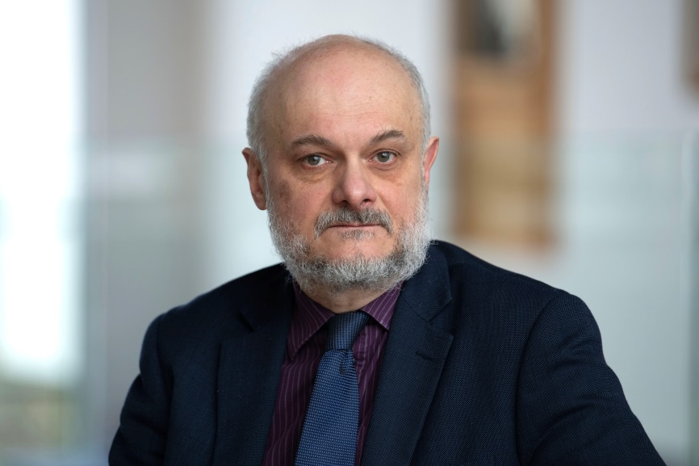

Date: 07.03.2023 (Tuesday)
Time: 19.00 (Central European Time).
Venue: Zoom
Registration: please, email us at michal.lachman@uni.lodz.pl to request a link to the meeting

